CHAPTER 2 miaverse
This chapter provides an overview of the miaverse ecosystem. Section 2.1 aims to describe the relationship between data containers utilized in miaverse. Section 2.2 details the packages involved, while Section 2.3 provides guidance on installing these packages.
miaverse (MIcrobiome Analysis uniVERSE) is an actively developed R/Bioconductor framework for microbiome downstream analysis. It becomes particularly relevant when working with abundance tables derived from sequencing data, whether from shotgun metagenomics or 16S rRNA sequencing. Before utilizing miaverse, sequencing data must undergo preprocessing to convert raw sequence reads into abundance tables.
miaverse consists of multiple R/Bioc packages and this online book that you are reading. The idea is not only to offer tools for microbiome downstream analysis but also to serve as a resource for valuable insights, offering guidance on conducting microbiome data analysis and developing effective microbiome data science workflows.
The key concept of miaverse lies in its utilization of SummarizedExperiment-based data containers. This design choice enhances interoperability and versatility within the broader Bioconductor framework, facilitating access to an expanding array of tools. In practice, this approach allows for the integration of promising methods from related fields, such as single-cell sequencing.
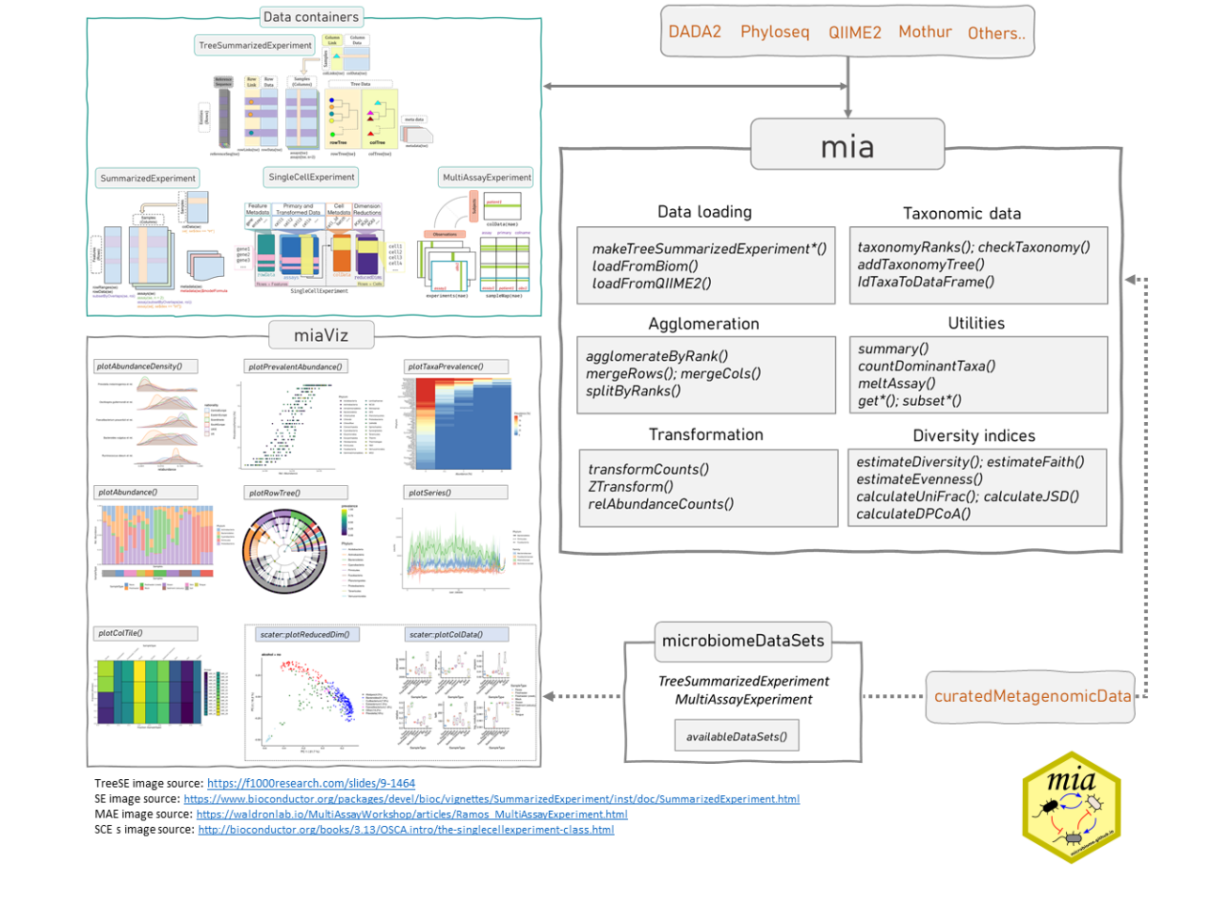
miaverse framework.
2.1 Data containers
As discussed, miaverse is built upon TreeSummarizedExperiment (TreeSE) data container. TreeSummarizedExperiment is expanded from SingleCellExperiment (SCE) by incorporating additional slots tailored for microbiome analysis. SingleCellExperiment class is designed for single-cell sequencing (Lun and Risso 2020). Bioconductor offers wide variety of tools for this field including online book Orchestrating Single-Cell Analysis in Bioconductor (OSCA) (Amezquita et al. 2020). SingleCellExperiment, on the other hand, is further derived from SummarizedExperiment (SE) class. This hierarchical relationship among data containers means that all methods applicable to SingleCellExperiment and SummarizedExperiment objects can also be applied to TreeSummarizedExperiment objects.
Amezquita, Robert, Aaron Lun, Stephanie Hicks, and Raphael Gottardo. 2020. Orchestrating Single-Cell Analysis with Bioconductor. Bioconductor. https://bioconductor.org/books/release/OSCA/.
- SummarizedExperiment (SE) (Morgan et al. 2020) is a generic and highly optimized container for complex data structures. It has become a common choice for analyzing various types of biomedical profiling data, such as RNAseq, ChIp-Seq, microarrays, flow cytometry, proteomics, and single-cell sequencing.
- SingeCellExperiment (SCE) (Lun and Risso 2020) was developed as an extension to store copies of data to same data container.
- TreeSummarizedExperiment (TreeSE) (R. Huang 2020) was developed as an extension to incorporate hierarchical information (such as phylogenetic trees and sample hierarchies) and reference sequences.
Morgan, Martin, Valerie Obenchain, Jim Hester, and Hervé Pagès. 2020. SummarizedExperiment: SummarizedExperiment Container. https://bioconductor.org/packages/SummarizedExperiment.
Lun, Aaron, and Davide Risso. 2020. SingleCellExperiment: S4 Classes for Single Cell Data.
Huang, Ruizhu. 2020. TreeSummarizedExperiment: A S4 Class for Data with Tree Structures.
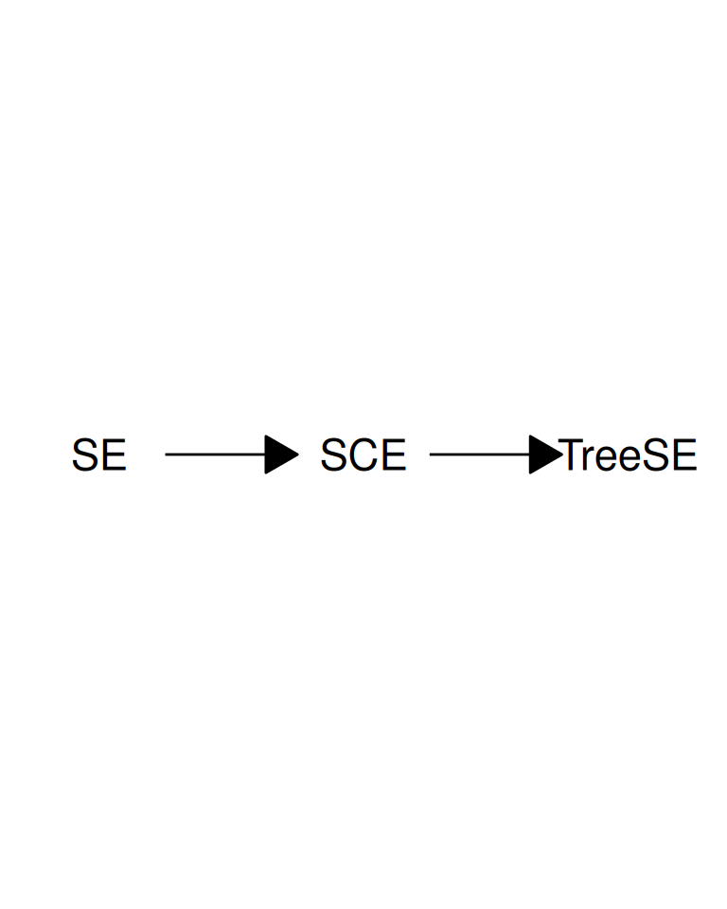
SummarizedExperiment is extended to SingleCellExperiment and it is further extended to TreeSummarizedExperiment.
MultiAssayExperiment (MAE) (Ramos et al. 2017) provides an organized way to bind several different data containers together in a single object. For example, we can bind microbiome data (in TreeSE container) with metabolomic profiling data (in SE) container, with (partially) shared sample metadata. This is convenient and robust for instance, in subsetting and other data manipulation tasks. Microbiome data can be part of multiomics experiments and analysis strategies. We highlight how the methods used throughout in this book relate to this data framework by using the TreeSE, MAE, and classes beyond.
Ramos, Marcel, Lucas Schiffer, Angela Re, Rimsha Azhar, Azfar Basunia, Carmen Rodriguez Cabrera, Tiffany Chan, et al. 2017. “Software for the Integration of Multiomics Experiments in Bioconductor.” Cancer Research. https://doi.org/10.1158/0008-5472.CAN-17-0344.
2.2 Package ecosystem
Methods for the(Tree)SummarizedExperiment and MultiAssayExperiment data containers are provided by multiple independent developers through R/Bioconductor packages. Some of these are listed below (tips on new packages are welcome).
Especially, Bioconductor packages include comprehensive manuals as they are required. Follow the links below to find package vignettes and other materials showing the utilization of packages and their methods.
2.2.1 mia package family
The mia package family provides general methods for microbiome data wrangling, analysis and visualization.
- mia: Microbiome analysis tools (Borman et al. 2024)
- miaViz: Microbiome analysis specific visualization (Borman, Ernst, and Lahti 2024)
- miaSim: Microbiome data simulations (Simsek et al. 2021)
- miaTime: Microbiome time series analysis (Lahti 2021)
- miaDash: Interactive analysis and visualisation (Benedetti and Lahti 2024)
Borman, Tuomas, Felix G. M. Ernst, Sudarshan A. Shetty, and Leo Lahti. 2024. Mia: Microbiome Analysis. https://github.com/microbiome/mia.
Borman, Tuomas, Felix G. M. Ernst, and Leo Lahti. 2024. miaViz: Microbiome Analysis Plotting and Visualization. https://github.com/microbiome/miaViz.
Simsek, Yagmur, Leo Lahti, Daniel Garza, and Karoline Faust. 2021. “miaSim r Package.” microbiome.github.io/miaSim.
Lahti, L. 2021. miaTime: Time Series Analysis.
Benedetti, Giulio, and Leo Lahti. 2024. miaDash: Shiny app for interactive analysis and exploration of microbiome data. https://github.com/microbiome/miaDash.
2.2.2 SE supporting packages
The following methods support (Tree)SummarizedExperiment.
- ALDEx2 (Gloor, Macklaim, and Fernandes 2016) for differential abundance analysis
- ampliseq (Straub et al. 2020) for amplicon sequencing analysis workflow using DADA2 and QIIME2
- ANCOMBC (Lin and Peddada 2020) for differential abundance analysis
- benchdamic (Calgaro et al. 2022) for benchmarking differential abundance methods
- curatedMetagenomicData contains standardized curated human microbiome data for novel analyses.
- DESeq2 (Love, Huber, and Anders 2014) for differential gene expression analysis
- HoloFoodR for interfacing EBI HoloFood resource
- IntegratedLearner for multiomics classification and prediction
- iSEEtree (Benedetti et al. 2025) for interactive visualisation of hierarchical data
- lefser (Khleborodova et al. 2024) for metagenomic biomarker discovery
- LimROTS for differential expression analysis for proteomics and metabolomics
- MaAsLin 3 (Nickols et al. 2024) for differential abundance analysis
- MGnifyR for accessing and processing MGnify data in R
  - MGnify Notebooks
  - EMBL-EBI MGnify user guides and resources
- microbiomeDatasets contains microbiome datasets loaded from Bioconductor’S ExperimentHub infrastructure
- MOFA2 (Argelaguet et al. 2018) for multi-omics factor analysis
- NetCoMi for network construction and Comparison
- radEmu (Clausen, Teichman, and Willis 2025) for differential abundance analysis
- tidySingleCellExperiment and tidySummarizedExperiment for data manipulation methods utilizing tidy paradigm
Gloor, Gregory B., Jean M. Macklaim, and Andrew D. Fernandes. 2016. “Displaying Variation in Large Datasets: Plotting a Visual Summary of Effect Sizes.” Journal of Computational and Graphical Statistics 25 (3): 971–79. https://doi.org/10.1080/10618600.2015.1131161.
Straub, Daniel, Nia Blackwell, Adrian Langarica-Fuentes, Alexander Peltzer, Sven Nahnsen, and Sara Kleindienst. 2020. “Interpretations of Environmental Microbial Community Studies Are Biased by the Selected 16S rRNA (Gene) Amplicon Sequencing Pipeline.” Frontiers in Microbiology 11. https://doi.org/10.3389/fmicb.2020.550420.
Lin, Huang, and Shyamal Das Peddada. 2020. “Analysis of Compositions of Microbiomes with Bias Correction.” Nature Communications 11 (1): 1–11. https://doi.org/https://doi.org/10.1038/s41467-020-17041-7.
Calgaro, Matteo, Chiara Romualdi, Davide Risso, and Nicola Vitulo. 2022. “Benchdamic: Benchmarking of Differential Abundance Methods for Microbiome Data.” Bioinformatics 39 (1). https://doi.org/10.1093/bioinformatics/btac778.
Love, Michael, Wolfgang Huber, and Simon Anders. 2014. “Moderated Estimation of Fold Change and Dispersion for RNA-Seq Data with DESeq2.” Genome Biol 15 (December): 550. https://doi.org/10.1186/s13059-014-0550-8.
Benedetti, Giulio, Ely Seraidarian, Theotime Pralas, Akewak Jeba, Tuomas Borman, and Leo Lahti. 2025. “iSEEtree: Interactive Explorer for Hierarchical Data.” Bioinformatics Advances 5 (1): vbaf107. https://doi.org/10.1093/bioadv/vbaf107.
Khleborodova, Asya, Samuel D Gamboa-Tuz, Marcel Ramos, Nicola Segata, Levi Waldron, and Sehyun Oh. 2024. “lefser: implementation of metagenomic biomarker discovery tool, LEfSe, in R.” Bioinformatics 40 (12): btae707. https://doi.org/10.1093/bioinformatics/btae707.
Nickols, William A., Thomas Kuntz, Jiaxian Shen, Sagun Maharjan, Himel Mallick, Eric A. Franzosa, Kelsey N. Thompson, Jacob T. Nearing, and Curtis Huttenhower. 2024. “MaAsLin 3: Refining and Extending Generalized Multivariable Linear Models for Meta-Omic Association Discovery,” December. https://doi.org/10.1101/2024.12.13.628459.
Argelaguet, Ricard, Britta Velten, Damien Arnol, Sascha Dietrich, Thorsten Zenz, John C Marioni, Florian Buettner, Wolfgang Huber, and Oliver Stegle. 2018. “Multi‐Omics Factor Analysis—a framework for unsupervised integration of multi‐omics data sets.” Molecular Systems Biology 14 (6): e8124. https://doi.org/https://doi.org/10.15252/msb.20178124.
Clausen, David S, Sarah Teichman, and Amy D Willis. 2025. “Estimating Fold Changes from Partially Observed Outcomes with Applications in Microbial Metagenomics.” https://arxiv.org/abs/2402.05231.
2.2.3 Other relevant packages
- CBEA (Nguyen QP, n.d.) for taxonomic enrichment analysis
- dar for differential abundance testing
- LinDA(Zhou et al. 2022) for differential abundance analysis
- MicrobiotaProcess (Xu et al. 2023) framework for the “tidy” analysis of microbiome and other ecological data
- microeco (Liu et al. 2020) microbiome analysis framework
- microSTASIS (Sánchez-Sánchez, Santonja, and Benítez-Páez 2022) for microbiota stability assessment via iterative clustering
- philr (Silverman et al. 2017) phylogeny-aware phILR transformation
- PLSDAbatch (Wang and Lê Cao 2023) for batch effect correction
- treeclimbR (S. Huang Ruizhu 2021) for finding optimal signal levels in a tree
- vegan (Oksanen et al. 2020) for community ecologists
- Tools for Microbiome Analysis site listed over 130 R packages for microbiome data science in 2023. Many of these are not in Bioconductor, or do not directly support the data containers used in this book but can be often used with minor modifications. The phyloseq-based tools can be used by converting the TreeSE data into phyloseq with convertToPhyloseq() (see Chapter 5).
Nguyen QP, Frost HR, Hoen AG. n.d. “CBEA: Competitive balances for taxonomic enrichment analysis.” PLoS Comput Biol 18 (5). https://doi.org/10.1371/journal.pcbi.1010091.
Zhou, Huijuan, Kejun He, Jun Chen, and Xianyang Zhang. 2022. “LinDA: Linear Models for Differential Abundance Analysis of Microbiome Compositional Data.” Genome Biology 23 (1): 95. https://doi.org/10.1186/s13059-022-02655-5.
Xu, Shuangbin, Li Zhan, Wenli Tang, Qianwen Wang, Zehan Dai, Lang Zhou, Tingze Feng, et al. 2023. “MicrobiotaProcess: A Comprehensive R Package for Deep Mining Microbiome.” The Innovation 4 (2): 100388. https://doi.org/10.1016/j.xinn.2023.100388.
Liu, Chi, Yaoming Cui, Xiangzhen Li, and Minjie Yao. 2020. “Microeco: An r Package for Data Mining in Microbial Community Ecology.” FEMS Microbiology Ecology 97 (2). https://doi.org/10.1093/femsec/fiaa255.
Sánchez-Sánchez, Pedro, Francisco J Santonja, and Alfonso Benítez-Páez. 2022. “Assessment of Human Microbiota Stability Across Longitudinal Samples Using Iteratively Growing-Partitioned Clustering.” Briefings in Bioinformatics 23 (2): bbac055. https://doi.org/10.1093/bib/bbac055.
Silverman, Justin D, Alex D Washburne, Sayan Mukherjee, and Lawrence A David. 2017. “A Phylogenetic Transform Enhances Analysis of Compositional Microbiota Data.” eLife 6. https://doi.org/10.7554/eLife.21887.
Wang, Yiwen, and Kim-Anh Lê Cao. 2023. “PLSDA-batch: A Multivariate Framework to Correct for Batch Effects in Microbiome Data.” Briefings in Bioinformatics 24 (2): bbac622. https://doi.org/10.1093/bib/bbac622.
Huang, Soneson, Ruizhu. 2021. “treeclimbR Pinpoints the Data-Dependent Resolution of Hierarchical Hypotheses.” Genome Biology 22 (2). https://doi.org/10.1186/s13059-021-02368-1.
Oksanen, Jari, F. Guillaume Blanchet, Michael Friendly, Roeland Kindt, Pierre Legendre, Dan McGlinn, Peter R. Minchin, et al. 2020. Vegan: Community Ecology Package. https://CRAN.R-project.org/package=vegan.
2.2.4 Open microbiome data
Hundreds of published microbiome datasets are readily available in these data containers (see Section 4.2).
2.3 Installation
2.3.1 Installing specific packages
You can install R packages of your choice with the following procedures.
Bioconductor release version is the most stable and tested version but may miss some of the latest methods and updates.
BiocManager::install("microbiome/mia")
Bioconductor development version requires the installation of the latest R beta version. This is primarily recommended for those who already have experience with R/Bioconductor and need access to the latest updates.
library(BiocManager)
install("microbiome/mia", version = "devel")
Github development version provides access to the latest but potentially unstable features. This is useful when you want access to all available tools.
library(remotes)
install_github("microbiome/mia")
2.3.2 Install key packages
Installing the core packages listed below is sufficient for training sessions and courses, as they provide the essential functionality required to run common tasks and most example workflows. You can then install additional packages as needed, depending on the specific requirements of your analysis.
Let us fist define a script to install packages.
install_packages <- function(pkg){
# Get packages that are already installed installed
pkg_installed <- pkg[ pkg %in% installed.packages() ]

# Get packages that need to be installed
pkg_to_install <- setdiff( pkg, pkg_installed )

# Loads BiocManager into the session. Install it if it not already
# installed.
if( !require("BiocManager") ){
install.packages("BiocManager")
library("BiocManager")
}

# If there are packages that need to be installed, installs them with
# BiocManager.
if( length(pkg_to_install) > 0 ) {
install(pkg_to_install, ask = FALSE)
}

# Load all packages into session. Stop if there are packages that were not
# successfully loaded.
pkgs_not_loaded <- !sapply(pkg, require, character.only = TRUE)
pkgs_not_loaded <- names(pkgs_not_loaded)[ pkgs_not_loaded ]
if( length(pkgs_not_loaded) > 0 ){
stop("Error in loading the following packages into the session: '",
paste0(pkgs_not_loaded, collapse = "', '"), "'")
}
return(TRUE)
}
The core packages include mia, miaViz, maaslin3 (for differential abundance), and mikropml (for supervised ML).
pkgs <- c("mia", "miaViz", "maaslin3", "mikropml")
install_packages(pkgs)
## [1] TRUE
2.3.3 Installing all packages
You can install all packages that are required to run every example in this book via the following command:
library(remotes)
install_github("microbiome/OMA", dependencies = TRUE, upgrade = TRUE)
Optionally, you can install all packages or just certain ones with the following script.
# URL of the raw CSV file on GitHub. It includes all packages needed.
url <- "https://raw.githubusercontent.com/microbiome/OMA/devel/oma_packages/oma_packages.csv"

# Read the CSV file directly into R
df <- read.csv(url)
packages <- df[[1]]
# Install packages
install_packages(packages)
2.3.4 Docker container
Installing all the packages might take some time, and sometimes there can be some troubles. To get quickly access to all packages, you might want to consider loading the Docker image. You can find more information from Section E.1.
2.3.5 Troubleshoot in installing
If you encounter installation issue related to package dependencies please see the troubleshoot page here and Chapter 29.
2.4 Interactive analysis
We also provide the Microbiome Analysis Dashboard (miaDash), a web app to interactively explore microbiome data through an intuitive Graphical User Interface (GUI). The app features a large part of the mia functionality and does not require any knowledge of R programming. This way, beginners can practice and learn the concepts of microbiome analysis while free from technical burdens. The app is hosted online at this address by the Finnish IT Center for Science (CSC). Feature requests and bug reports can be submitted here.
Summary
- TreeSummarizedExperiment is derived from SummarizedExperiment class.
- miaverse is based on TreeSummarizedExperiment data container.
- We can borrow methods from packages utilizing SingleCellExperiment and SummarizedExperiment.
Exercises
Goal: Learn related packages and resources.
Exercise 1: Introduction to miaverse
- How SummarizedExperiment, SingleCellExperiment and TreeSummarizedExperiment are related?
- Go and explore this CSV file. Which packages you have already used? Which packages are new to you?
- Search each package from internet. What tools each package offers?
- Go to the discussion forum. Here you can get help and ask questions if you come up with one.
- Visit Chapter 30 for additional resources.

